## Questions for Rich

**Oregon data:**

Who should I contact about the Oregon beach sampling data that I see in the PNWHAB Bulletin? The sites include: Clatsop, Sunset, Seaside, Cannon Beach, Garibalidi, etc.

**Particulate domoic acid data coverage:**

The particulate domoic acid data coverage is lower than I expected: 389 observations collected since 2015 largely from Long Beach and Twin Harbors. Does this seem about right?

**Definitions of a few data fields:**

I was hoping you could confirm my interpretation of a few data fields:

All years

* **Pseudo-nitzschia Count (Cells/L):** density of all PN species
* **% Pseudo-nitzschia In Bloom:** % of bloom that is any PN species

2008 and before

* **% P-n p./m. =** % of PN in bloom that are *P. multiseries / pungens* (long/narrow)
* **% P-n a./f./h. =** % of PN in bloom that are *P. australis / fraudulenta / heimii* (short/broad)
* **% P-n pd./d./c. =** % of PN in bloom that are *P. pseudodelicatissima / delicatissima / cuspidata* (small/narrow)

2009 and after

* **% P-n large** = % of PN in bloom that are in the ‘seriata’ (large) size class
* **% P-n small** = % of PN in bloom that are in the ‘delicatissima’ (small) size class

I was also hoping you could define the following data fields for me:

* **​​μS/cm** - is this conductivity?
* **ORP** - this only occurs in the 2010 data

## 

## Figures

### Particulate domoic acid (ng/L)

### 

### Pseudo-nitzschia (cells/L)

### 

### Large Pseudo-nitzschia (cells/L)

### 

### Small Pseudo-nitzschia (cells/L)

### 

### Temperature (°C)

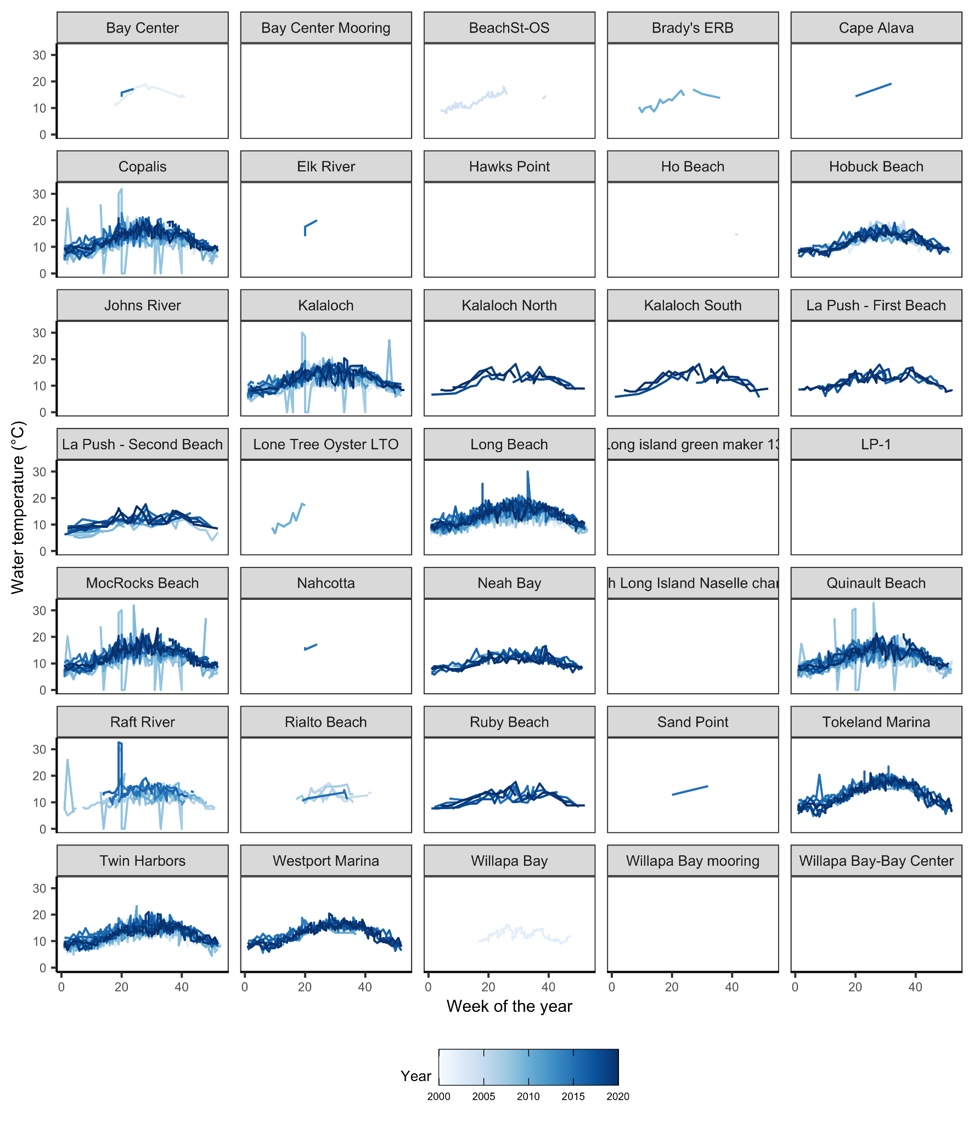

### 

### Salinity (psu)

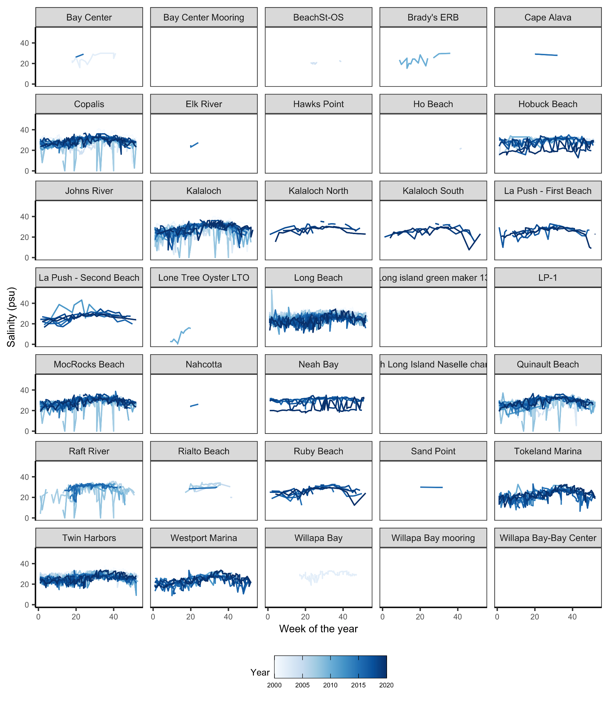

### 

### Dissolved oxygen (mg/L)